## **Steubenville Ohio: Reading case study**

*13th September 2025*

Steubenville and the Success for All Foundation

The school district of Ohio has implemented the science of reading programme [Success for All](https://www.successforall.org/), developed by Nancy Madden and Professor Robert Slavin of Johns Hopkins University.

The Fischer Family Foundation supported the Success for All Foundation and established it in the UK in 1999.

In 2021, Success for All UK merged with FFT Education and forms the basis of the literacy programmes used by more than 1000 schools in the UK.

What’s special about Steubenville

* Since 2008, 93% - 100% of Steubenville third graders (UK Year 4) have scored as proficient on a state reading assessment. This is compared to a 66% pass rate across Ohio.
* According to data from the [Educational Opportunity Project](https://edopportunity.org/) at Stanford University. Steubenville has routinely scored in the top 10% or better of schools nationwide for third grade reading, sometimes scoring as high as the top 1%.
* Steubenville is an economically depressed area. Nearly 80% of Steubenville students receive free or reduced lunches, and the state of Ohio considers almost every one of Steubenville’s students to be “economically disadvantaged.”

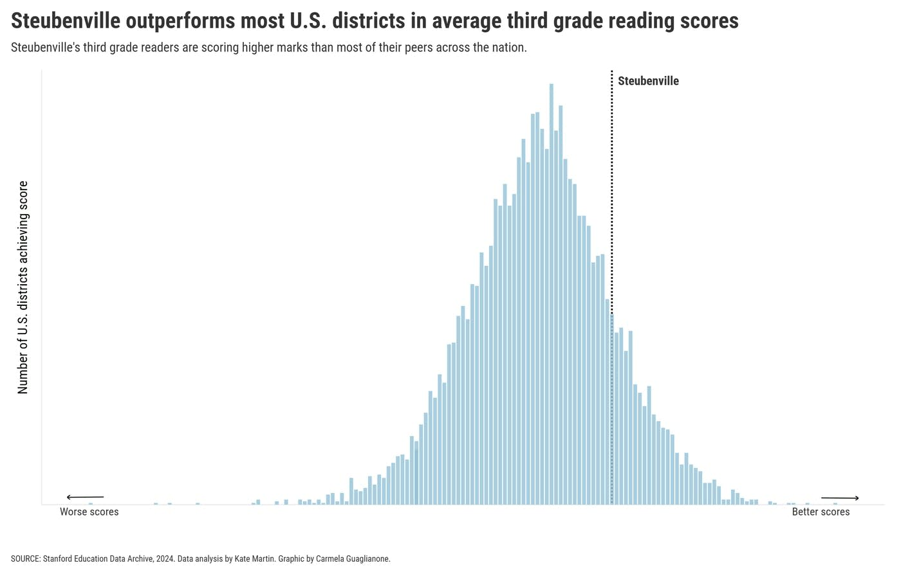

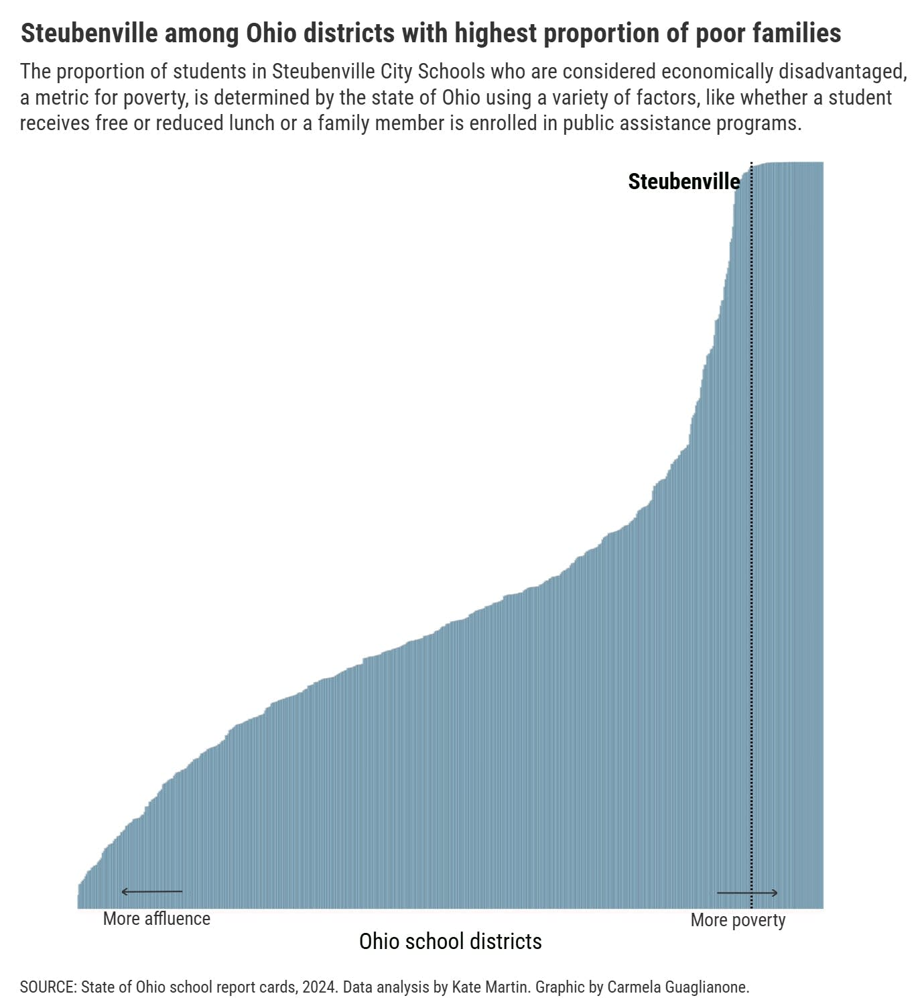

Key elements of the approach

* Subsidized pre-K. Nearly 80% of Steubenville’s children attend preschool, which costs just $100 per month for full-day classes and is free for the poorest families. The program begins at age 3, and teachers encourage students to talk in complete sentences, which helps them later when they start to learn to read and write. Nationwide, fewer than half of children attend a preschool program.
* Attendance. Steubenville uses attendance contests to motivate students to come to school — and deploys a rapid response team when they don’t. A child is considered chronically absent if they miss school 10% of the time or more. Steubenville has a much lower percentage of chronically absent students than most school districts in Ohio. In a class of 30 children, Steubenville is likely to have only a couple of chronically absent students, whereas the average district across the state may have as many as six or seven.
* Small reading classes. All the students in Steubenville’s elementary schools have reading class at the same time. That allows students to be grouped with others at the same reading level — even if they’re in a different grade. And reading classes can be small. Some have just six kids. Steubenville is able to have so many small reading classes because every teacher leads one, even gym teachers.
* Time to practice. Steubenville does something called “cooperative learning,” where kids work in pairs and small groups based on their skill level. While this is no substitute for direct instruction from a teacher, it provides something really important: time to practice.
* Tutoring for kids who need it. Kids who need extra help get one-on-one tutoring in addition to the daily 90-minute reading class. The tutors include staff, community volunteers and local high school and college students.
* Consistency. While many schools change reading curricula frequently, Steubenville has used the same program for the past 25 years called Success for All.

*This case study on Steubenville is adapted from the article by Kate Martin, Carmela Guglianone and Emily Hanford: ‘The Outlier: Most school districts have lots of kids who struggle with reading. This one is different’ AMP Reports, February 2025. Available at:* [*https://www.apmreports.org/story/2025/02/20/steubenville-ohio-reading-success-for-all*](https://www.apmreports.org/story/2025/02/20/steubenville-ohio-reading-success-for-all)

Other references include:

Chilkoti, Olivia. July 2025. ‘Success for All gets kids reading. Why don’t more schools use it?’ AMP Reports [online] Available at: <https://www.apmreports.org/story/2025/07/24/success-for-all-gets-kids-reading-why-dont-more-schools-use-it>

Chenoweth, Karin. 2009. ‘How It's Being Done: Urgent Lessons from Unexpected Schools’ Harvard Education Press.

<https://www.successforall.org/sfa-on-sold-a-story-2/>